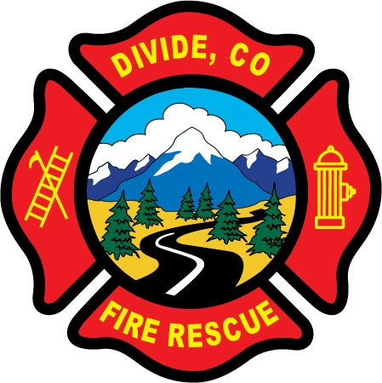 | Divide Fire Protection District  PO Box 941 Phone: 719-687-8773  103 Cedar Mountain Rd. E-Mail: dividefire@dividefire.com  Divide, CO 80814

Notice of Meeting Cancellation
pursuant to CRS § 32-1-903(2):

This is public notice that the meetings normally held on the fourth Tuesday of the month will be cancelled for the month of September and October, due to board member availability issues.

The meetings on the second Tuesday will be held as usual.

Tuesday, September 23, 2025 – cancelled
Tuesday, October 7, 2025 – held as usual
Tuesday, October 21, 2025 – cancelled
Tuesday, November 11, 2025 – held as usual

Date of Notice: September 12, 2025

