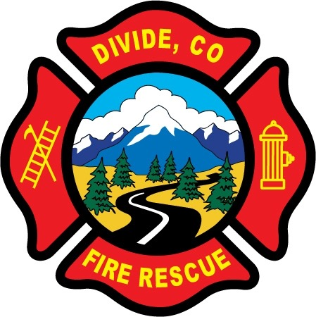

DIVIDE FIRE PROTECTION DISTRICT

Board of Directors Meeting

Shoemaker Fire Station, 103 Cedar Mountain Road (Mail: PO Box 941), Divide Colorado, 80814
February 14th, 2023 at 6:00 p.m.

MINUTES OF THE REGULAR MEETING

1. Call to Order
President Josh Weatherill called to order the regular meeting of the Board of Directors of the Divide Fire Protection District (DFPD) at 18:00.
Board members present:
Josh Weatherill – President Steed Lopez – Secretary
Barry Pleshek – Vice President Dennis Luttrell – Director
Allison Mosser – Treasurer

2. Review and Approve Agenda
Motion by Director Mosser to approve the agenda with the addition of Item 9.c. Station Manager Position. Second by Director Luttrell. The motion passed unanimously.

3. Review, Approve, and Sign Minutes of Prior Meetings
Motion by Director Lopez to approve the minutes of the previous regular meeting. Second by Director Luttrell. The motion passed unanimously.

4. Pension Board Meeting
The Pension Board Meeting was called to order by President Allison Mosser at 18:02. In attendance were all District Board members and Member-at-Large Ryan Kennedy. Motion by Ryan Kennedy to retroactively approve the pension credits compiled and submitted by Mosser and Diana Perkins. Second by Director Luttrell. The motion passed unanimously. The Pension Board Meeting was adjourned at 18:10 and the regular meeting resumed.

5. Public Comment – No public comment.

6. Financial Matters
A. Financial Reports – Attached.
B. Purchase Orders – none.

Diana Perkins mentioned that an invoice would be coming from the City of Cripple Creek for approximately $1500 for a light pole that was damaged by E24 while responding to a mutual aid call. Motion by Director Mosser to approve the financials and paying of the bills. Second by Director Lopez. The motion passed unanimously.

7. Chief’s Report – Attached. Deputy Chief Kennedy reported on the accidents involving Jeff Remley involving the light pole in Cripple Creek and damage to an UPRAD ambulance due to backing into a tree. Kennedy reported that Remley has been suspended from driving for a period of 60 days. Director Pleshek asked about the District’s current driver training. There was a concern that this was not being documented properly enough to protect the District. Diana Perkins reported that the insurance pool does not provide or sponsor any in-person driver training but only online classes. The District’s existing training program offers some online driver training that would be appropriate for refresher courses. The board recommended for Kennedy to have member Remley do a refresher course, and look into assigning those courses to the general membership. They discussed the need for increased documentation of what the courses cover and individual documentation in member’s folders showing completion of the course.
A. Business Meeting Attendees – Business meeting for March 6th. Director Pleshek will attend with Director Lopez as backup.

8. Administrator Report – Attached.
A. Accident Investigation Form – Diana Perkins presented an Accident Investigation Form to be filled out by an officer and signed by the Chief after an accident or injury. The purpose of the form is to determine what actions might avoid such accidents in the future. She also submitted proposed Handbook language to include filling out the form in the accident/injury process. Motion by Director Mosser to approve the proposed Handbook language. Second by Director Pleshek. The motion passed unanimously.
The board also signed the renewal IGA for Northeast Teller County Fire District to continue performing repair work.

9. Old Business

- Policies / Handbook – The Handbook was amended as noted above in section 8.A. Director Mosser reported that legal counsel estimated $2500 to make Handbook changes to include and adjust for the hiring of a paid Chief and eventually two paid firefighters.

- Chief Hiring Process – Tom O’Connor reported that the committee met on February 7th and identified five candidates to be interviewed. Two of the candidates withdrew from consideration. The remaining three candidates will be interviewed by zoom next week. O’Connor submitted rates for health insurance to the board for from PSHCG which groups special district public employees together to get better rates, and so will cover a single employee. The board discussed how the budget might be tweaked to allow for a health insurance stipend this year before the mill levy increase kicks in. It was agreed that some money could be used from the $10000 designated for recruitment, and the rest could come from the additional time it is taking to find a candidate. Motion by Director Mosser to approve offering the prospective Chief candidate a stipend of up to $2000 to be used towards a health insurance plan at the candidate’s discretion, applied toward actual expense with no refund for unused funds. Second by Director Luttrell. The motion passed unanimously.

10. New Business

- No new business.

11. Executive Session – none.

12. Adjournment
Motion by Director Pleshek to adjourn the meeting. Second by Director Lopez. The motion passed unanimously. The meeting was adjourned at 19:32. The next regular meeting will take place on Tuesday, March 14th, 2023 at 6:00 p.m.

APPROVAL

We attest that the foregoing minutes, which have been approved by the affirmative majority vote of the Board of Directors of the Divide Fire Protection District, are a true and accurate record of the meeting held on the date stated above.

__________________________________________________ ______/______/_______
Name and Title Date

__________________________________________________ ______/______/_______
Name and Title Date

