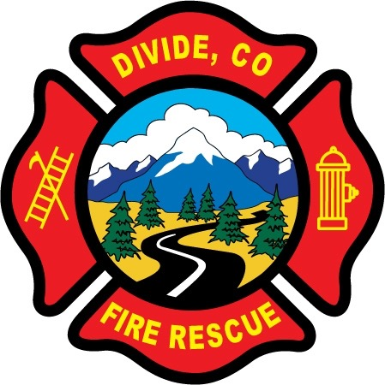

DIVIDE FIRE PROTECTION DISTRICT

Board of Directors Meeting

Shoemaker Fire Station, 103 Cedar Mountain Road (Mail: PO Box 941), Divide Colorado, 80814
December 13th, 2022 at 6:00 p.m.

MINUTES OF THE REGULAR MEETING

1. Call to Order
President Josh Weatherill called to order the regular meeting of the Board of Directors of the Divide Fire Protection District (DFPD) at 18:00.
Board members present:
Josh Weatherill – President Steed Lopez – Secretary
Barry Pleshek – Vice President Dennis Luttrell – Director
Allison Mosser – Treasurer

2. Review and Approve Agenda
Motion by Director Pleshek amending the agenda to add item 10, Executive Session, to discuss personnel matters related to Martin Guthardt pursuant to §24-6-402(4)(f), C.R.S. and approving as amended. Second by Director Lopez. The motion passed unanimously.

3. Review, Approve, and Sign Minutes of Prior Meetings
Motion by Director Luttrell to approve the minutes of the previous regular meeting. Second by Director Lopez. The motion passed unanimously.

4. Public Comment – No public comment.

5. Financial Matters
A. Financial Reports – Attached.
B. Purchase Orders – none.

Motion by Director Luttrell to approve the paying of the bills. Second by Director Mosser. The motion passed unanimously.

6. Chief’s Report – Deputy Chief Kennedy advised some members would be moving to reserve or associate due to call/training stats. These members will be required to meet quarterly minimums. Diana Perkins also requested that they be required to remain current with administrative compliance issues as well.
A. Business Meeting Attendees – Business meeting for January is moved to January 9th. Director Mosser will attend with Director Weatherill as backup.

7. Administrator Report – Attached.
A. Potential Applicant Issue – The board reviewed an anonymous potential applicant who advised the department he would have a felony and DUI on his background check if he were to apply. Based on that information, the board recommended this applicant wait three years past his felony conviction before applying.

8. Old Business

- Policies - Updates to Handbook – Director Mosser submitted the handbook including amendments for the criminal background check compliance and the state FAMLI program. Motion by Director Mosser to approve the amended handbook version 4.1. Second by Director Luttrell. The motion passed unanimously. Other updates related to the hiring of a paid chief will be tabled until the district is further into that process.

- Station Security – No activity.

- Budget – Resolution 2022-07 Resolution to Certify Mill Levies
Motion by Director Mosser to pass. Second by Director Luttrell. The motion passed unanimously.
Resolution 2022-08 Resolution to Adopt a Budget
Motion by Director Mosser to pass. Second by Director Luttrell. The motion passed unanimously.
Resolution 2022-09 Resolution to Appropriate Funds
Motion by Director Mosser to pass. Second by Director Luttrell. The motion passed unanimously.

- Chief Hiring Process – Tom O’Connor presented a proposed job posting and timeline. The board expressed a desire to be more involved in the interview process, and it was agreed to work out the details. O’Connor and Director Mosser will make a few minor amendments and then Mosser will submit the document to legal for final approval. The job will be posted after final legal review.

- Treasurer Position – Director Mosser reported that she would not be resigning in January but would continue at least through the upcoming election. She would like to see some overlap with a potential new treasurer for training purposes if that is possible.

9. New Business

- Status of Medical ALS/BLS – Diana Perkins reported a conversation with Dr. DeWall where he expressed that although paramedics can technically perform any activities within their scope of practice, he recommended that the department as a whole decide if they are going to commit to being an ALS or BLS provider, so that he himself and other agencies know exactly what to expect on scene. The board confirmed that the department will remain a BLS provider. Deputy Chief Kennedy will communicate that to the volunteers.

10. Executive Session – President Weatherill called the meeting into Executive Session at 21:02 to discuss personnel matters related to Martin Guthardt pursuant to §24-6-402(4)(f), C.R.S. The Executive Session ended at 21:37 and the regular meeting resumed at 21:38.
.

11. Adjournment
Motion by Director Pleshek to adjourn the meeting. Second by Director Luttrell. The motion passed unanimously. The meeting was adjourned at 21:38. The next regular meeting will take place on Tuesday, January 10th, 2023 at 6:00 p.m.

APPROVAL

We attest that the foregoing minutes, which have been approved by the affirmative majority vote of the Board of Directors of the Divide Fire Protection District, are a true and accurate record of the meeting held on the date stated above.

__________________________________________________ ______/______/_______
Name and Title Date

__________________________________________________ ______/______/_______
Name and Title Date

